**Notice**

23.09.2025

Due to Natural Disaster and heavy Water Logging, the College with its all Departments will remain closed today (23.09.2025.)

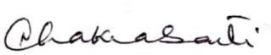



Principal

Heramba Chandra College